

CSIT 321 - Project

Final Report

Project Topic: CSIT-24-S3-08

(Multi-factor transaction authorisation based on QR code)

Group Number: FYP-24-S3-11

Member’s Name | UOWID | Email
Matthew Chin Yu Kang | 7768990 | mykchin001@mymail.sim.edu.sg
Randall Lim Shi Hao | 8107002 | rshlim001@mymail.sim.edu.sg
Teo Wei Zhi Zakary | 7769258 | wzzteo001@mymail.sim.edu.sg
Mahina Lim Fong Jia | 8378885 | mfjlim002@mymail.sim.edu.sg
Ryzlan Afiq Bin Roslan | 7895124 | ryzlanab001@mymail.sim.edu.sg

Supervisor
Mr Chua Zong Fu

Assessor
Mr Japit Sionggo

1. Introduction 3
2. Project Scope 3
2.1 Background 3
2.2 What was asked 3
2.3 what we delivered 4
3. Deliverables 4
3.1 Project management 4
3.2 Product related 4
3.3 Project Objective 4
4. Research done for this project 5
4.1 Why A Social Platform Application 5
4.2 Competing products 6
4.2.1 Robin 7
4.2.2 Skedda 7
4.2.2 Teem 7
4.2.3 RoomZilla 7
4.3 Web security 8
4.4 Why did we choose this project 8
4.5 Tech Stack 8
4.5.1 Continuous Deployment 9
4.5.2 NextJs 9
4.5.3 Java 9
4.5.4 MySQL 10
5. Stretch Goals 10
5.1 Application for Tablet 10
5.2 Azure Active Directory (AAD) 11
6. User stories 13
Webpage 13
Mobile 15
7. Development Methodology 16
7.1 Team Hierarchy 16
7.2 Scrum Model 16
7.3 Work Breakdown Structure 17
8. Business Model 18
8.1 Value Propositions 18
8.2 Customer Segments 19
8.3 Channels 19
8.4 Customer Relationships 20
8.5 Future Plan 21
9. WireFrames 22
9.1 Main Website 22
9.2 Mobile Application 22
9.3 Public Site 24
Other stuff below(do we still need this?) 24
Meeting 1 31
Meeting 2 32
Meeting 3 33
Meeting 4 34
Meeting 5 35
Meeting 6 36
Meeting 7 37
Meeting 8 38

1. Introduction
A transaction is a fundamental interaction or exchange between parties where something of value, such as goods, services, money, or information, changes hands based on mutual agreement regarding the terms and conditions. Transactions are integral to various contexts, including financial markets, business operations, and everyday interactions, providing the basis for economic activity and organisational efficiency.
In our project, transactions play a crucial role in the booking system for meeting rooms. When a user selects a date and time to reserve a room, a transaction is initiated to exchange information and verify availability. This involves a seamless process where the application checks the room's availability, generates a QR code for the confirmed booking, and triggers multi-factor authentication (MFA) to ensure secure user confirmation. This series of interactions ensures that the booking is accurately recorded and that only authorised users can access the reserved meeting room.
This project aims to create a secure and efficient room booking system that leverages modern technologies to facilitate transactions. By integrating real-time availability checks, QR code generation, and MFA, the system ensures that the booking process is user-friendly and secure. This approach not only enhances user experience but also improves the overall management of meeting room reservations, contributing to better organisational efficiency and resource utilisation.

2. Project Scope

2.1 Background
The project aims to design and develop a secure transaction authorisation protocol based on QR code. To authorise an online transaction, the user will need to use his/her biometric information and a mobile device with a QR code scanner to complete the transaction. The protocol can be implemented via a web interface.

The protocol will be executed between a web interface and an app on a mobile device(with QR code scanning function and biometric authentication function).

2.2 What was asked
- Develop a secure transaction authorisation protocol
- Generate QR code
- Create an app to scan QR code
- Authorise using biometric information

2.3 what we delivered
We successfully delivered a robust, cloud-based SaaS platform tailored to meet the needs of large or medium organisations in managing their meeting room bookings securely and efficiently. This solution streamlines the process of room reservations, allowing employees to easily book meeting spaces from any device, while ensuring a high level of security. A key feature of the platform is its integration with multi-factor authentication (MFA) for room access, providing an added layer of safety by ensuring that only authorised personnel can enter reserved rooms.
With its cloud infrastructure, the system is designed to be highly scalable, dynamically adjusting database capacity to accommodate the needs of growing organisations. Whether a company operates a single building or a multi-location campus with hundreds of rooms, the platform can effortlessly handle the increased demand, adapting to the number of rooms or employees as required. This flexibility allows companies to manage their meeting spaces without worrying about outgrowing the system. Additionally, the platform’s secure data handling ensures that all booking and access information remains private and protected, meeting the stringent data security requirements of enterprise clients.
Overall, our solution simplifies room management, enhances physical security with MFA-protected access, and supports the evolving needs of expanding organisations, empowering companies to focus on their core activities while providing employees with a secure, user-friendly booking experience.

3. Deliverables

3.1 Project management
- Scope: Comprehensive documentation of the project's scope within the final report, which outlines the objectives, expected outcomes, and technical specifications of the secure transaction authorization protocol using QR codes and biometric verification.
- Stretch Goal: Description of additional, ambitious goals beyond the original scope, detailed in the final report.
- SCRUM Report: Detailed reports on the SCRUM methodology adopted during the project lifecycle, included in the final report. This section should also encompass all SCRUM meeting minutes, providing insights into the decision-making processes, sprint outcomes, and project adaptations over time.
- Work Breakdown Structure: A detailed breakdown and schedule of all project tasks, divided into manageable sections. This should include timelines for each phase, responsibilities assigned to each team member, and milestones to gauge project progress.

3.2 Product related
- Research report [Final Report]
- Requirements report [Technical Report]
- System design report [Technical Report]
- Prototype: An incomplete, but functional version of the final product. Of course, it will continue to be worked on after this point.
- Source code
- Testing document/report [Technical Report, Use Cases]
- User manual [User Manual]
- Web Interface: A web interface that provides the QR code that will be used for the transaction. The QR code displayed here has to be the only one the mobile application can interact with.
- App: A mobile application that is used to authenticate the transaction brought about by the QR code. It is only through this application that the transaction can be carried out, and only with the QR code provided by the web interface.

3.3 Project Objective
The objective of the project is to create the protocol as addressed in the background information. Not only does the protocol need to complete transactions successfully, it must be able to consistently do so. As such, the app needs to ensure that it can scan and authenticate each transaction for different accounts, and to do so more than once per account.

- Users
  - Employees
  - VIP (director)
  - Administrators
- Functionality
  - Application should be able to scan QR code from web interface
- QR code
  - QR code to be generated from the web interface
  - Authorisation transaction to be completed via scanning from mobile app
- Web Interface
  - Generates QR code for application to scan
- Server
  - Server send email to recipient
- Mobile Application
  - Able to access user’s biometric information
  - Able to scan QR code from web interface
  - Able to execute the protocol from the QR code
  - Able to enter the PIN on the phone
- Security
  - Transactions to only be carried out via web interface and application
  - Application may only execute the transaction protocol via QR codes generated by the web interface
  - User’s biometric information is known only to themselves
  - Admin has a break glass password in the event for emergency

4. Research done for this project
Non Sensitive information (don't need MFA)
- Education
- Public Information

Sensitive Information
- Healthcare
- Payment
- Social (Room Booking system)

4.1 Why A Social Platform Application
With Multi-Factor Authentication (MFA) often being the key to safeguard against unauthorised access. We argue that MFA may not be necessary for certain types of data, such as educational materials and public information. These types of data are generally intended for broad access and dissemination, and the imposition of MFA can create unnecessary barriers to entry.

In the healthcare sector, the sensitivity and confidentiality of patient data make robust security measures imperative. MFA is crucial in this context because it significantly reduces the risk of unauthorised access and other sensitive information. We recognise that healthcare data breaches can lead to severe consequences, including identity theft, insurance fraud, and violations of patient privacy. By implementing MFA, we add an extra layer of security that helps to ensure that only authorised personnel can access patient information, thereby safeguarding against data breaches and enhancing trust in the healthcare system.

The financial sector is a prime target for cybercriminals due to the direct monetary gain that can be achieved through unauthorised access. For payment systems, MFA is essential to protect against fraud and unauthorised transactions. When we make online purchases or transfer money, we need to ensure that our financial information is secure. MFA helps to achieve this by requiring additional verification steps, such as a one-time password sent to a mobile device, in addition to the standard username and password. This additional layer of security makes it significantly more difficult for cybercriminals to gain access to financial accounts, thus protecting both consumers and businesses from financial loss and reputational damage.

In social applications such as booking systems for travel, events, or appointments, the protection of user data is also critical. These systems often store personal information, payment details, and travel itineraries, making them attractive targets for hackers. We must recognize the importance of maintaining user trust and ensuring the security of their information. Implementing MFA in booking systems helps to verify user identities and prevent unauthorised access to personal accounts. This not only protects sensitive information but also enhances user confidence in the security of the platform. By using MFA, we can mitigate risks associated with unauthorised changes to bookings, fraudulent transactions, and data breaches.

Developing a new app for social aspects like a booking system is more feasible compared to healthcare or payment apps. The existing apps in healthcare and payment sectors have undergone extensive development and rigorous security testing to meet the highest standards. They are also continuously updated to address new security threats and improve functionality, making it difficult for new entrants to offer superior solutions. By focusing on booking systems, we can leverage existing technologies and security measures, including MFA, to create a secure and user-friendly platform without facing the overwhelming challenges present in the healthcare and payment sectors.

4.2 Competing products
There are a couple of products that are somewhat achieving what we’re aiming to accomplish with AppName. Some products include Robin,Skedda, Teem and RoomZilla.

4.2.1 Robin
Robin is a workplace management technology that streamlines operations to increase in-office efficiency. The platform, which includes desk and room booking software as well as intelligent workplace automation and analytics, allows employees to reserve anything they need at work. Robin has been trusted by thousands of worldwide enterprises since 2014 to provide long-term and scalable workplace optimization solutions.

What we’re interested in is the way their booking system functions. Robin users can use an app or their web interface to do their bookings and such. They also feature Microsoft Outlook and Google Calendar integration, which allows for smooth scheduling directly from your current calendar applications

4.2.2 Skedda
Skedda is a software that simplifies workspace booking and maintenance. It mostly benefits administrators and managers who manage space in settings such as offices, libraries, and studios. The technology makes space management more efficient by minimising the complexity and time required for scheduling and reserving spaces. Skedda seeks to eliminate the headache of manually allocating space in the modern office. It is positioned as the appropriate solution for shared office space, desks, meeting rooms, and hybrid workplace scenarios.

4.2.2 Teem
The Teem by Eptura cloud-based technology helps businesses to maximise workspace use and employee productivity. The service enables employees to effortlessly schedule conference rooms and manage meeting resources, while also delivering data-driven insights into an organisation's meeting and collaboration practices. This comprehensive platform provides organisations with the tools to make educated decisions and improve operational efficiency.

4.2.3 RoomZilla
Roomzilla is a piece of software that makes it easier to book and organise conference rooms in a workplace, hence increasing productivity and maximising space use. It avoids scheduling conflicts, double reservations, and wasted resources, providing a more efficient office administration experience. Roomzilla's user-friendly interface allows customers to rapidly search available rooms, choose preferred time slots, and secure bookings, removing the need for human coordination of room availability. This saves time and effort in managing workplace space.

4.3 Web security
Security wise, we decided to go with HTTPS as all the products listed above use HTTPS.
HTTPS is an encrypted version of HTTP. Which is the protocol for transferring data between web browsers and servers. When visiting an HTTPS-enabled website, the connection between the browser and the servers is encrypted, protecting all sensitive data from being spied on by malicious individuals. That data includes all forms of confidential information, such as login credentials, payment information, general browsing activities and in our case; transaction of information.

HTTPS operates on a request-response model, requiring a secure sockets layer (SSL) and transport layer security (TLS) certificate for encryption. These certificates are digital documents that verify a website's identity, establishing an encrypted connection.

The process begins with the user's web browser connecting to a website using HTTPS. The SSL/TLS certificate is sent by the website's server, containing the website's public key (encryption key). The browser verifies the certificate, ensuring it is valid and issued by a trusted authority. Once verified, the browser and server establish an encrypted connection by exchanging keys.

The browser uses the server's public key to encrypt information, which can only be decrypted by the server's private key. All data transferred between the browser and server is encrypted, ensuring it cannot be read by anyone intercepting the data. The server decrypts the received data using the private key, processes it, and sends back the requested information, which is also encrypted. The browser then decrypts the incoming data and displays the website content to the user.

4.4 Tech Stack
Our application employs a carefully selected tech stack designed to deliver a fast, reliable, and seamless experience across both web and mobile platforms. We have opted for MySQL as our shared database solution, ensuring consistency and reliability for both the web and mobile applications. For our web application, we chose Next.js for its server-side rendering capabilities and API route integrations, which facilitate robust, secure communication with the database, enhancing the overall user experience. The mobile application leverages Java to capitalise on its proven stability and compatibility with Android devices, offering high performance and rich features. This unified architecture streamlines data handling, providing a consistent and integrated user experience across all platforms.

4.4.1 CI/CD Pipeline for Deployment
For our website's development, we will create a dedicated GitHub repository where the team will collaborate using the Next.js framework. To streamline deployment, we have chosen Vercel as our hosting platform.
Key Benefits of Vercel Integration:
- Continuous Deployment: Vercel automatically sets up a continuous deployment pipeline. Any code pushed to the main branch of our GitHub repository will immediately trigger a new deployment, ensuring fast and consistent updates.
- Optimised Builds: With Vercel, we benefit from optimised builds and fast performance tailored specifically for Next.js projects.
- Automatic Scaling: Vercel handles traffic spikes effortlessly with its built-in automatic scaling capabilities.
- Developer-Centric Features: The user-friendly interface, reliability, and developer-oriented features of Vercel make it an ideal choice for efficient application deployment.
Include screenshots here illustrating:
- GitHub to Vercel Integration Overview
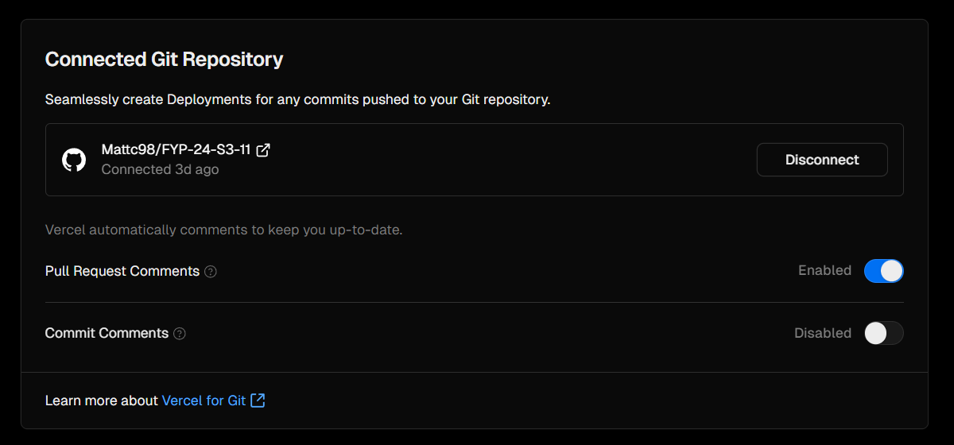
- Example Deployment Logs on Vercel's Dashboard
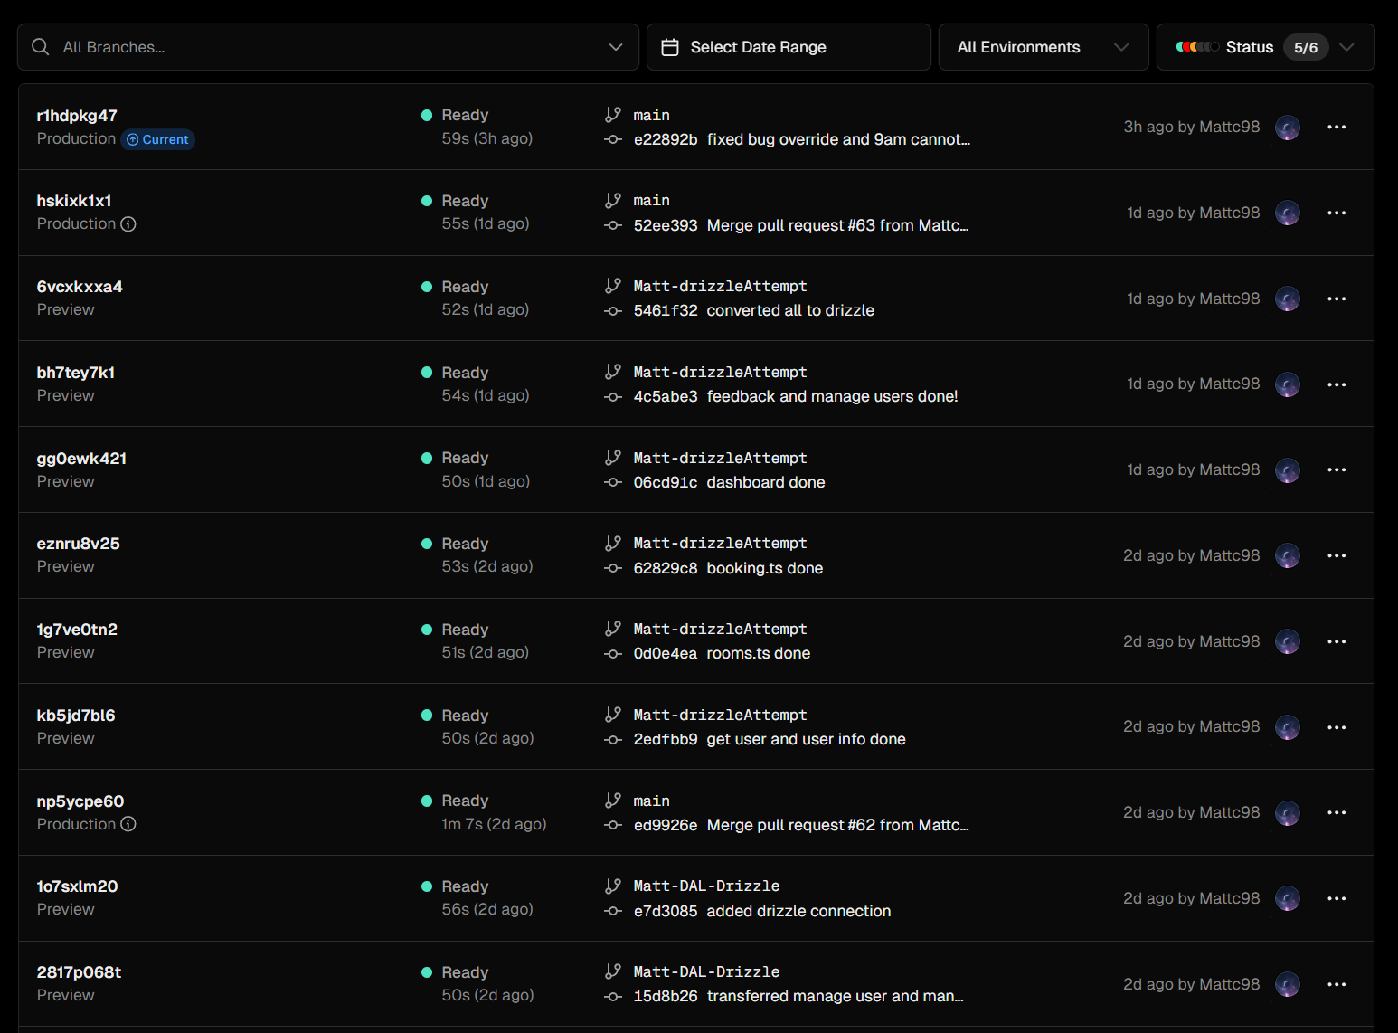
- Github Pull requests
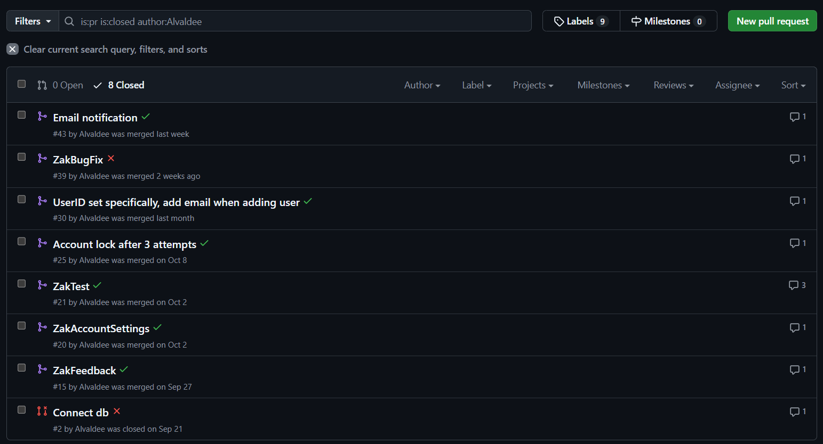
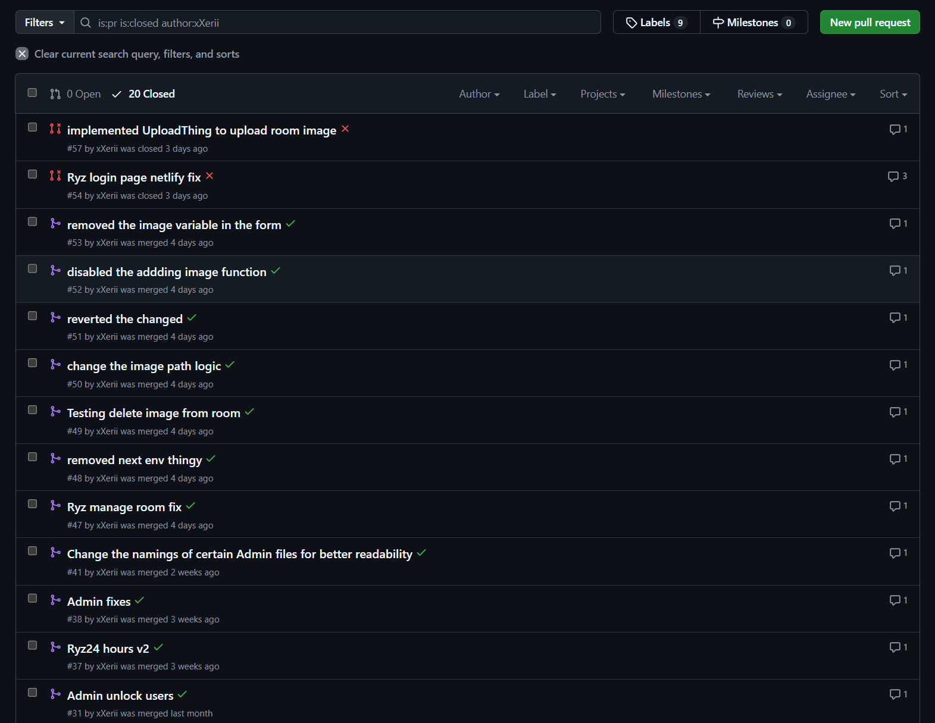
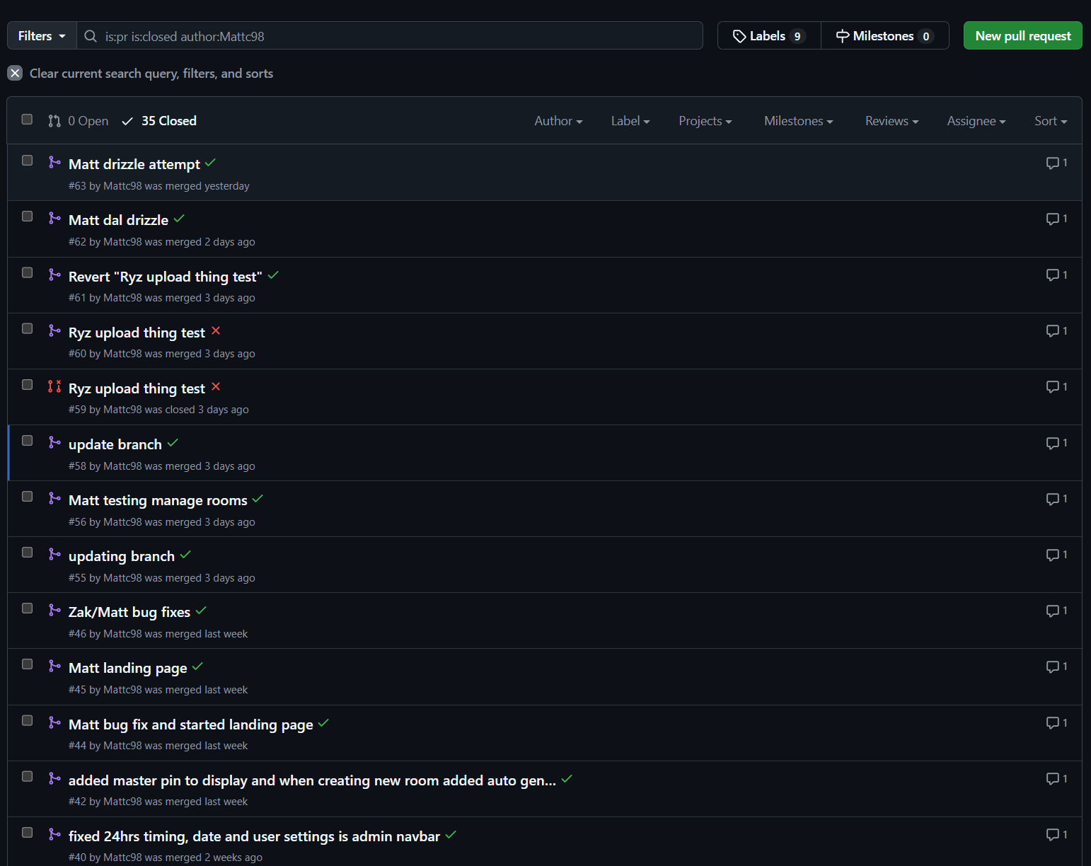
- User Interface for Managing Deployments in Vercel
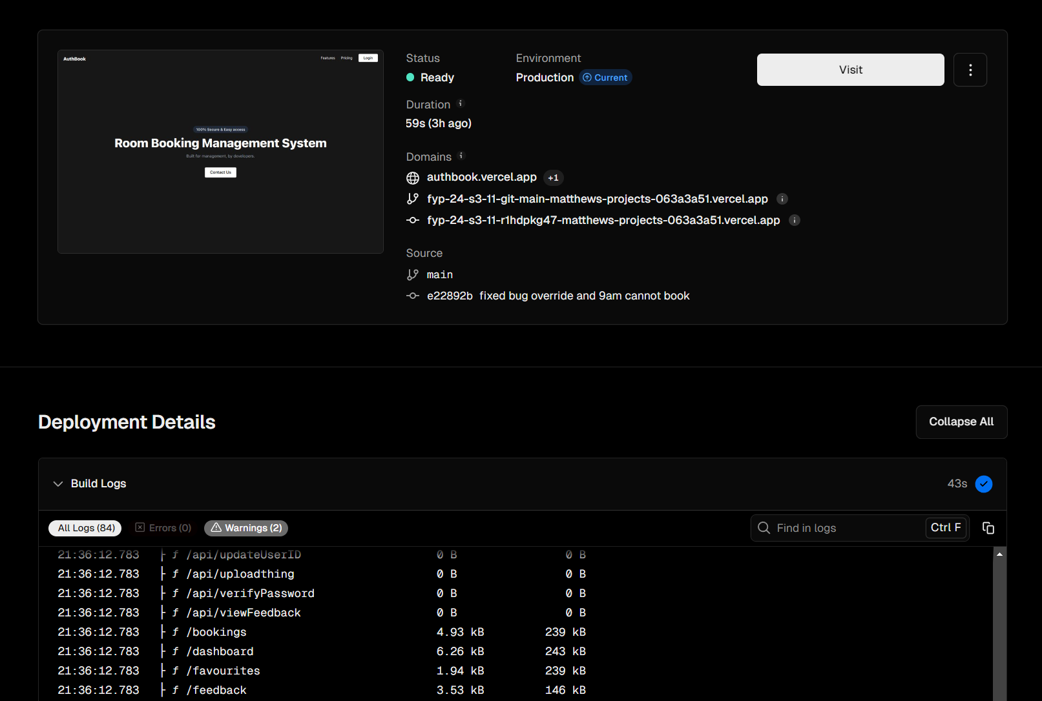

4.4.2 Next.js
We chose Next.js as our web development framework for several reasons. It builds on React and offers out-of-the-box server-side rendering, making it SEO-friendly and providing faster page load times and improved user engagement. The built-in routing, API routes, and other features streamline our development process, allowing us to focus on core functionality without dealing with excessive setup. While we considered frameworks like Angular, Vue.js, and newer options such as Qwik, Next.js' combination of server-side rendering, flexibility, and a strong ecosystem made it the most practical choice for rapidly developing our Minimum Viable Product (MVP) and collecting user feedback.

4.4.3 Java for Mobile Development
Java remains a leading choice for Android application development due to its stability, strong multithreading support, and integration with the Android SDK. Our prior experience with Java allows us to maintain rapid development cycles while leveraging its mature libraries to create robust, performant mobile applications. We considered Kotlin, React Native, and Swift, but ultimately decided on Java due to its vast documentation, community support, and ability to integrate deeply with Android’s native features, ensuring maximum performance and flexibility.

4.4.4 MySQL
MySQL serves as our database solution for its dependability, high performance, and scalability. It supports ACID-compliant transactions, ensuring data integrity across our web and mobile applications. MySQL’s indexing and efficient query processing enhance the responsiveness of our application, essential for delivering optimal user experiences. We evaluated other databases such as PostgreSQL, MongoDB, and Oracle, but MySQL's balance of simplicity, feature richness, and community support made it the best choice, particularly given our team’s familiarity with the platform. As an open-source solution, MySQL also minimizes costs and offers a wide range of tools for database management and administration.

4.4.5 Cloud Server
AWS was selected as our cloud service provider for its scalability and comprehensive suite of cloud solutions. We will deploy our Spring Boot application on AWS EC2, creating a scalable REST API server to communicate with our mobile app. Additionally, AWS RDS (Relational Database Service) will host our MySQL database, providing automated backups, security, and maintenance. This managed infrastructure minimizes administrative overhead while ensuring seamless integration between our backend components.

4.4.6 Drizzle ORM
To bridge the gap between our Next.js backend and MySQL, we are leveraging Drizzle ORM. Drizzle offers a modern, type-safe approach to database interaction in JavaScript and TypeScript, making it a powerful tool for managing our data models and queries. Unlike traditional ORMs that may be cumbersome and slow, Drizzle focuses on lightweight, composable query building, which allows for precise and efficient database operations. This makes our codebase more maintainable and improves productivity by reducing boilerplate code while enhancing type safety and error checking.
Drizzle’s flexible architecture integrates seamlessly with Next.js, enabling rapid iteration during development while maintaining strong adherence to data validation and integrity rules. This integration, combined with its compatibility with MySQL, makes Drizzle an excellent choice to meet our project requirements without compromising on performance or scalability. Its focus on modern development practices, such as immutability and composability, aligns well with our agile approach, ensuring that our database interactions are predictable, robust, and easy to debug.
Additionally, Drizzle ORM offers built-in protection against SQL injection attacks. By using parameterized queries and automatically escaping user inputs, Drizzle minimises the risk of injection vulnerabilities that can compromise application security. This security feature ensures that any data provided by the user is treated safely and processed correctly, adding another layer of defence to our application’s backend and reinforcing trust and safety for our users.

4.4.7 Uploadthing
Uploadthing is a modern file handling and uploading solution designed to streamline the process of uploading, managing, and serving files in web applications. It offers a robust, developer-friendly API that simplifies the implementation of secure and scalable file uploads. With built-in support for features like file transformations, access controls, and seamless integration with modern frameworks, Uploadthing is an essential tool for managing user-generated content efficiently in any web-based project.

4.4.8 Conclusion
In selecting our tech stack, we evaluated each technology based on our team’s expertise and its suitability for meeting project requirements. By choosing Next.js for the web, Java for mobile development, MySQL as our database, and leveraging Drizzle ORM for data management, we maximised our team's strengths and ensured a cohesive, high-performing solution that can scale with user demand. This strategic approach enables us to build and refine our application rapidly, delivering a consistent, reliable user experience across all platforms.

The decision table link: “https://docs.google.com/spreadsheets/d/19mW6q1wEsh0nYeJOReeHb31Op8zgL_N1/edit?gid=1911573079#gid=1911573079”

4.5 Break Glass
The term “break glass” is used for particular accounts, bypassing normal security controls for a system in emergencies. As a means of backup in such situations, a break-glass account is used. Such an account is highly privileged, having access to critical systems, but in order to prevent misuse, it must undergo constant monitoring and testing. The account is also pre-staged and distributed with minimal delay, to ensure easy access during an emergency. However, we intend to apply this method to passwords that users may use.

4.5.1 Emergency Examples
Break-glass access is ideally provided only in emergencies where normal procedures prove to be insufficient or unaccessible. A few examples for our case include:
- The user may forget to bring their phone, which is required for scanning the QR code and biometrics.
- Multi-factor authentication (MFA) is required but unavailable due to a network outage.
- Account problems due to a cyberattack – access to all accounts was removed.
- Account problems due to a locked password – the password was typed incorrectly too many times.

4.5.2 Process
The important factor to consider is to determine who is able to be given emergency break-glass access and under what circumstances. We will do this via creating break-glass passwords, able to bypass ordinary access controls such as MFA.
These emergency passwords should be managed and distributed to ensure quick availability with minimum administrative delay.
In the event of an emergency, the break-glass procedure typically looks like this:
- The user forgets to bring their phone, which shuts them out of biometric authentication and receiving their OTP. Here, they can contact an admin in order to request a break-glass password to access the room.
- The admin will then verify the user’s ID via alternate means, and only after that do they enter the break-glass password.
- The break-glass password will temporarily allow the user to access the room, and this access will be logged for later auditing.
- However, for security purposes, the password is to be changed once the break glass password is used.

5. Network diagram
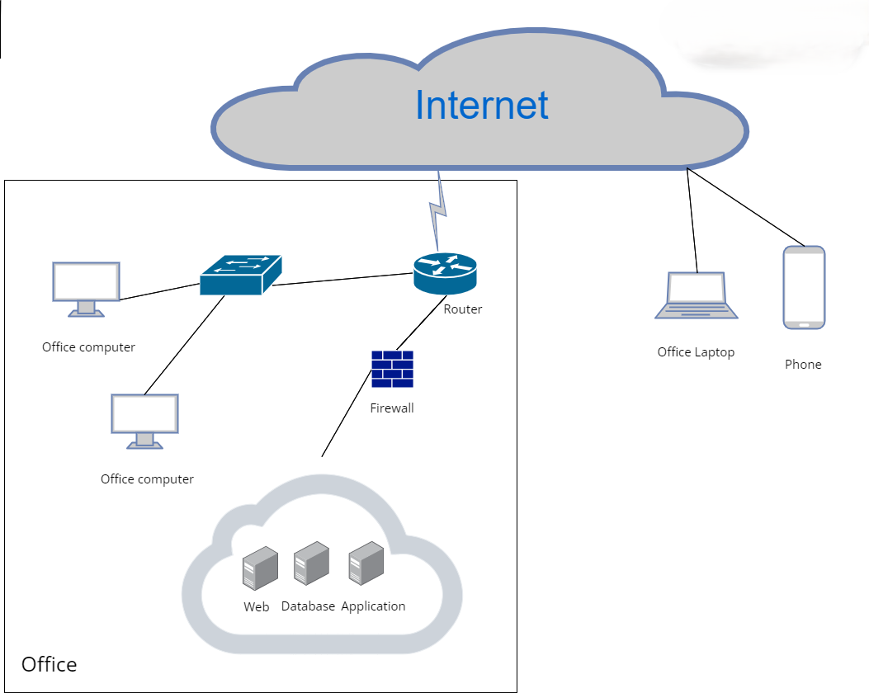

For our server architecture, we have opted to utilise cloud-based solutions extensively. Specifically, our web server will be hosted on GitHub, providing a robust platform for code management and deployment. Meanwhile, our database will be hosted on AWS, leveraging its scalable infrastructure to handle our data needs efficiently.

Using a Cloud Server: Benefits
- Space Efficiency: By using cloud servers, we significantly reduce the physical space required for server hardware within our office environment.
- Cost Savings: Cloud solutions are often more cost-effective, reducing the need for upfront capital expenditure on hardware and ongoing maintenance costs.
Cons of Cloud Servers:
- Recovery Time and Availability: One potential drawback is the slower recovery time compared to setups with built-in redundancy. This not only delays the resumption of normal operations but also affects the availability of services to users if there is an issue with the cloud services. Redundancy allows for quick failover, merely switching to a backup server if the primary server fails.
Firewall Configuration:
- Our network diagram highlights the strategic placement of a firewall between the router and the server. This setup is crucial for protecting our most sensitive data assets (often referred to as the "crown jewels"). The firewall scrutinizes both internal and external packets attempting to access the server. It ensures that only whitelisted packets are allowed through, while others are dropped, bolstering our security measures.
Backup and Recovery Strategy:
- We recommend backing up the server through periodic snapshots, taken every six months. This approach is cost-effective and helps in maintaining a recent backup of our system state.
- However, a downside to this strategy is the potential impact on recovery times during server downtimes. While redundancy would allow for immediate failover to an alternate server, the costs are considerably higher. Additionally, the reliance on periodic snapshots every six months could result in data loss if a failure occurs before the next snapshot is taken. This gap between snapshots means that any data generated after the last snapshot and before the failure will not be recoverable, potentially impacting business operations and data integrity.

6. Stretch Goals

6.1 Application for Tablet
Create an application for the a tablet to be placed at every meeting room, This application will show a calendar and the user has to select the date and time which will then check if there is a booking, it will then generate a QR code for the user to scan and authorise user via MFA which would allow entry.
Features
- User Interface
  - Calendar View: Display a calendar where users can select the date and time for their meeting.
  - Time Slots: Allow users to select specific time slots and check room availability.
  - Booking Confirmation: Show a confirmation screen with booking details.
- Room Availability Check
  - Real-time Availability: Integrate with the organisation's calendar system (e.g., Google Calendar, Microsoft Outlook) to check room availability in real-time.
  - Conflict Resolution: Alert users if the selected time slot is already booked and suggest alternative times.
- QR Code Generation
  - Unique QR Code: Generate a unique QR code for each booking, which users can scan to gain entry.
  - Expiration: Set QR codes to expire after a certain period to enhance security.
- Multi-Factor Authentication (MFA)
  - MFA Integration: Use Azure AD or another authentication provider to implement MFA.
  - Authorization: Ensure that only authorised users can book and access meeting rooms.

6.2 Azure Active Directory (AAD)
Integrating Azure Active Directory (AAD) into a mobile application enables you to authenticate users, manage access, and provide a seamless single sign-on (SSO) experience.
As we continue to enhance the security and user experience of our mobile application, a key stretch goal is to integrate Azure Active Directory (Azure AD) authentication. This integration will provide several benefits, including improved security, streamlined user management, and a seamless single sign-on (SSO) experience for our users. Below, I outline the objectives, implementation steps, and expected outcomes of this stretch goal.
Objectives
- Enhance Security:
  - Leverage Azure AD's robust security features, such as Multi-Factor Authentication (MFA) and Conditional Access policies, to protect user data and ensure secure access to the application.
- Streamline User Management:
  - Centralised authentication and user management, reducing the administrative overhead of managing separate authentication systems for different applications.
- Improve User Experience:
  - Implement SSO to allow users to authenticate once and gain access to multiple applications without repeatedly entering credentials.
Implementation Steps
- Register the Application in Azure AD:
  - Register the mobile application in the Azure portal to obtain necessary identifiers such as the client ID and redirect URI.
- Configure Azure AD for the Mobile App:
  - Set up the mobile application to use Azure AD for authentication by integrating the Microsoft Authentication Library (MSAL).
- Develop and Test the Integration:
  - Implement the MSAL library in the mobile application's codebase for both iOS and Android platforms.
  - Configure the application to handle authentication responses and securely store tokens.
  - Conduct thorough testing to ensure that the integration works seamlessly and securely.
- Implement Advanced Security Features:
  - Enable and configure Multi-Factor Authentication (MFA) to add an extra layer of security.
  - Set up Conditional Access policies to control how and when users can access the application.
- Deploy and Monitor:
  - Deploy the updated application with Azure AD integration to production.
  - Monitor the integration for any issues and gather user feedback to make necessary improvements.
- Data backup and recovery
  - Employ Azure Backup for scalable and automated backup solutions.
  - Schedule regular Full Backups and configure Incremental Backups to capture only changes, minimising storage use.
  - Develop a clear strategy with recovery time objectives (RTO) and recovery point objectives (RPO).
Expected Outcomes
- Increased Security: By utilising Azure AD's advanced security features, we can better protect our users' data and prevent unauthorised access.
- Simplified User Management: Centralised authentication through Azure AD will streamline user management and reduce administrative complexity.
- Enhanced User Experience: Users will benefit from a seamless SSO experience, allowing them to access our application and other connected services with a single login.
Conclusion
Integrating Azure AD authentication into our mobile application represents a significant step forward in enhancing both security and user experience. By achieving this stretch goal, we will not only improve the overall functionality and appeal of our application but also position ourselves to better meet the security demands of our users in today's digital landscape.

7. User stories

Webpage
User

1. As a user, I want to login, so that my account remains secure from unauthorised access
2. As a user, I want to search for available rooms based on date and time, so that I can find a suitable room for my meeting
3. As a user, I want to view my upcoming bookings, so that I can manage my reservations and plans
4. As a user, I want to update a booking, so that I can update the date/time as the meeting was postponed.
5. As a user, I want to delete an existing booking, because I no longer need it
6. As a user, I want to view my account’s page, so that I know what its details are.
7. As a user, I want to update my account password, so that I can keep my account safe with a strong unique password
8. As a user, I want to give feedback about the room, so that the admin can rectify the issue
9. As a user, I want to logout so that my account remains secure
10. As a user, I want to save my favourites rooms, so that my future booking experience can further simplified
11. As a user, I want to create a booking, so that I can host my meeting.

Admin
1. As an Admin, I want to edit rooms within the system, so that I can manage the room availability and details
2. As an Admin, I want to review all room bookings feedback, so that I can ensure proper usage and prevent any issues.
3. As an Admin, I want to update a user account, so that I can update the user roles, password and email accounts.
4. As an Admin, I want to view user account, so that I can assist users with account-related issues
5. As an Admin, I want to create a user account, so that I can add new employee to the team
6. As an Admin, I want to logout so that my account remains secure
7. As an Admin, I want to login to the website, so that I can administer the bookings
8. As an Admin, I want to delete a user account, Once an employee leaves the team.
9. As an Admin, I want to unlock account that has been lock, so that the user can use the account again

Director
1. As a Director, I want to login to the website, so that I can create a booking for my meeting
2. As a Director, I want to search for rooms based on date/time, so that I can find a suitable room for my meeting
3. As a Director, I want to override a booking, so that I can host my meeting on this specific date/ time as that is the only time I am available
4. As a Director, I want to view all my bookings, so that I can check that I have the correct room and date/time booked
5. As a Director, I want to delete a booking, so that I can free up the room as the meeting was cancelled
6. As a Director, I want to update a booking, so that I can update the date/time as the meeting was postponed
7. As a Director, I want to logout so that my account remains secure
8. As a Director, I want to book exclusive rooms (rooms not available to normal users, like a big room), so I can have an option of more rooms to use
9. As a Director, I want to give feedback about the room, so that the admin can rectify the issue.
10. As a Director, I want to save my favourites rooms, so that my future booking experience can further simplified
11. As a Director, I want to create a booking, so that I can host my meeting.
12. As a Director, I want to view my account, so that I know what its details are.
13. As a Director, I want to update my account, so that I can update my password.

Mobile
User
1. As a user, I want to login, so that my account remains secure from unauthorised access.
2. As a user, I want to logout so that my account remains secure.
3. As a user, I want to view my booking, so that I can check that I have the correct room and date/time booked
4. As a user, I want to scan the qr code so that I can access the room.
5. As a user, I want to scan my biometric data to verify my identity, so that I can receive a PIN to securely access a meeting room.

Director
1. As a Director, I want to login so that my account remains secure from unauthorised access.
2. As a Director, I want to logout so that my account remains secure.
3. As a Director, I want to view my booking, so that I can check that I have the correct room and date/time booked
4. As a Director, I want to scan the qr code so that I can access any room.
5. As a Director, I want to scan my biometric data to verify my identity, so that I can receive a PIN to securely access a meeting room.

8. Development Methodology

8.1 Team Hierarchy
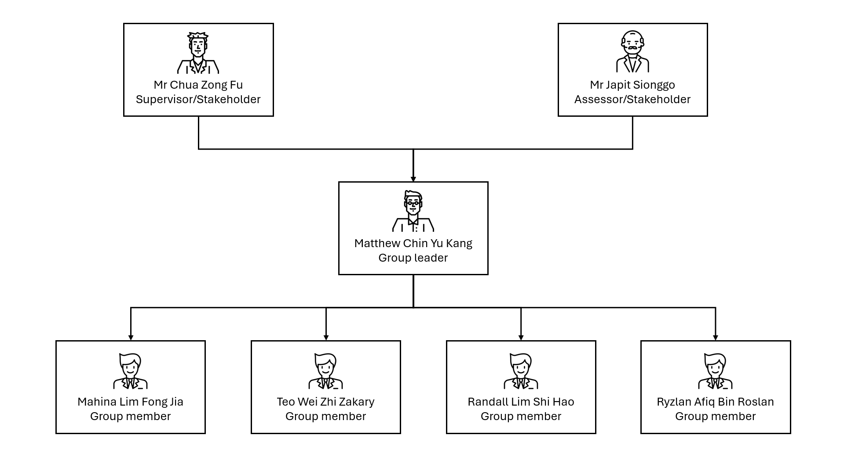

8.2 Scrum Model
For this project, we use Scrum due to its support for adaptive planning, evolutionary development, and continual improvement, facilitating flexible responses to change. By dividing our work into 10 two-week sprints, we ensure regular opportunities to assess and refine our direction, aligning closely with changing requirements and expectations. Additionally, sprint meetings offer a platform for transparency, allowing us to share updates, discuss challenges, and ensure all team members are informed and engaged. This approach helps us address issues promptly and keeps everyone in sync with the project's progress.

8.3 Work Breakdown Structure

Item | Task | Start Date | End Date | Completion days | User
1 | Learning Stack | 08/07/2024 | 19/07/2024 | 12 | All
2 | Introduction | 20/07/2024 | 27/07/2024 | 7 | Matthew, Mahina
3 | Project Scope | 20/07/2024 | 27/07/2024 | 7 | Matthew
4 | Deliverables | 20/07/2024 | 27/07/2024 | 7 | Mahina, Randall
5 | Research | 20/07/2024 | 02/08/2024 | 14 | Zakary, Ryzlan
6 | Stretch Goal | 20/07/2024 | 27/07/2024 | 7 | Matthew
7 | User Stories | 27/07/2024 | 30/07/2024 | 4 | All
7.1 | User Stories (Mobile) | 27/07/2024 | 30/07/2024 | 4 | Mahina
7.2 | User Stories (Webpage) | 27/07/2024 | 30/07/2024 | 4 | Zakary, Ryzlan, Randall, Matthew
8 | Business model | 03/08/2024 | 07/08/2024 | 5 | Randall
9 | Non functional Requirement | 03/08/2024 | 07/08/2024 | 5 | Mahina, Matthew
10 | Functional Requirement | 03/08/2024 | 07/08/2024 | 5 | Mahina, Matthew
11 | Project Purpose | 03/08/2024 | 07/08/2024 | 5 | Zakary
12 | Prototyping Web | 03/08/2024 | 25/08/2024 | 23 | Ryzlan
13 | Use case description | 10/08/204 | 16/08/2024 | 7 | All
13.1 | Use case description (Mobile) | 10/08/204 | 16/08/2024 | 7 | Mahina
13.2 | Use case description (Webpage) | 10/08/204 | 16/08/2024 | 7 | Matthew , Randall, Zakary
14 | Use case diagram | 10/08/204 | 16/08/2024 | 7 | Mahina
15 | WireFrame | 17/08/2024 | 30/08/2024 | 14 | Mahina, Zakary
16 | Sequence Diagram | 17/08/2024 | 13/09/2024 | 28 | All
17 | Database Design | 17/08/2024 | 5/09/2024 | 20 | Matthew, Randall, Mahina
18 | Prototyping Mobile | 31/08/2024 | 13/09/2024 | 14 | Ryzlan
19 | Presentation slide | 08/09/2024 | 18/09/2024 | 11 | All
20 | Functional Hierarchy | 14/09/2024 | 18/09/2024 | 5 | Ryzlan
21 | Hosting Database | 19/09/2024 | 22/09/2024 | 4 | Ryzlan, Zakary
22 | Hosting webpage | 19/09/2024 | 22/09/2024 | 4 | Matthew, Mahina
23 | Web Page for login and logout | 19/09/2024 | 27/09/2024 | 9 | Ryzlan, Matthew
24 | Mobile for login and logout | 19/09/2024 | 11/10/2024 | 23 | Randall, Mahina, Zakary
25 | CRUD for User and Director Room booking  User stories (User 2,3,4,5,11 Director 2,4,5,6,8,11) | 28/09/2024 | 11/10/2024 | 14 | Matthew
26 | Create spring boot and host it on AWS (EC2) | 28/09/2024 | 11/10/2024 | 14 | Mahina, Zakary
27 | Mobile view booking | 28/09/2024 | 11/10/2024 | 14 | Mahina, Zakary, Randall
28 | User and director view/update account  User stories (User 6,7  Director 12,13) | 28/09/2024 | 04/10/2024 | 7 | Matthew
29 | User and Director give feedback  User stories (User 8  Director 9) | 05/10/2024 | 11/10/2024 | 7 | Zakary
30 | Director override a booking  User Stories(Director 3) | 05/10/2024 | 11/10/2024 | 7 | Matthew
31 | User and Director save favourites room  User stories (User 10 Director 10) | 05/10/2024 | 11/10/2024 | 7 | Matthew, Ryzlan
32 | Admin edit room  User stories (Admin 1) | 12/10/2024 | 18/10/2024 | 7 | Ryzlan
33 | Admin review all room  User stories (Admin 2) | 12/10/2024 | 18/10/2024 | 7 | Ryzlan
34 | Admin CRUD user account  User stories (Admin 3, 4, 5, 8) | 19/10/2024 | 25/10/2024 | 7 | Ryzlan, Zakary
35 | Admin Unlock lock account User stories (admin 9) | 19/10/2024 | 25/10/2024 | 7 | Ryzlan
36 | Mobile scan QR code  User Stories (User 4, Director 4) | 12/10/2024 | 18/10/2024 | 7 | Mahina, Ryzlan
37 | Mobile Biometric | 12/10/2024 | 18/10/2024 | 7 | Ryzlan, Zakary
38 | Mobile Email PIN | 19/10/2024 | 25/10/2024 | 7 | Mahina
39 | Email notification for override. (Webpage) | 26/10/2024 | 01/11/2024 | 7 | Zakary, Matthew
40 | Break glass password (webpage) | 26/10/2024 | 01/11/2024 | 7 | Matthew
41 | Break glass password (Mobile) | 26/10/2024 | 01/11/2024 | 7 | Mahina
42 | Mobile Testcase | 26/10/2024 | 01/11/2024 | 7 | Mahina
43 | WebpageTestcase | 26/10/2024 | 01/11/2024 | 7 | Matthew
44 | User Manual | 26/10/2024 | 08/11/2024 | 14 | Randall, Matthew
45 | Record Video | 01/11/2024 | 08/11/2024 | 7 | All
46 | Landing page | 01/11/2024 | 08/11/2024 | 7 | Matthew
47 | Deployment Diagram | 01/11/2024 | 08/11/2024 | 7 | Mahina, Zakary
48 | Bug Fixes (Mobile) | 26/10/2024 | 08/11/2024 | 14 | Mahina, Ryzlan
49 | Bug Fixes (Webpage) | 26/10/2024 | 08/11/2024 | 14 | Matthew, Ryzlan, Zakary
50 | Edit ERD and populate database | 01/11/2024 | 08/11/2024 | 7 | Zaraky
51 | Webpage hardening (Drizzle ORM) | 09/11/2024 | 13/11/2024 | 5 | Matthew
52 | Overall Design and CSS of the website | 09/11/2024 | 13/11/2024 | 5 | Matthew
54 | Edit Sequence Diagram | 09/11/2024 | 13/11/2024 | 5 | Ryzlan, Randall, Mahina
55 | Edit Use case Description | 09/11/2024 | 13/11/2024 | 5 | Mahina, Matthew, Ryzlan, Randall
56 | Video editing | 09/11/2024 | 13/11/2024 | 5 | Ryzlan
57 | Final presentation slide | 09/11/2024 | 13/11/2024 | 5 | all
58 | Final check document | 09/11/2024 | 13/11/2024 | 5 | All

CRUDS
- C = create
- R = Read
- U = Update
- D = Delete
- S = Search

9. Business Model

9.1 Value Propositions
The mission of this project is to develop and deploy an application that makes use of a web interface, a QR code, and the user’s biometric information within the application. This will be used to book certain rooms for use.

The application and website will require an account to log in. The web interface will generate the QR code which will be scanned using the mobile application. Once a transaction has been made between the system and the user, the system will provide a pin which will be the password for the room and will become accessible to them.

9.2 Customer Segments
The main users of this product are companies whose members need to hold meetings in certain rooms, as such they will make use of the webpage to book the meeting room and they use the QR code to access the room.
The targeted audience segment for this application consists primarily of medium to large enterprises, establishing it firmly within a business-to-business (B2B) model. These businesses, particularly in sectors such as technology, finance, and consulting, require sophisticated space management solutions to handle their meeting room efficiencies effectively. By adopting this application, companies can enhance resource allocation, streamline administrative processes, and improve the overall workplace environment, thereby boosting productivity and collaboration among teams.

9.3 Channels
Our product can be promoted via channels such as social media advertising. It is a good way to reach our target customers who make use of such platforms. Additionally, our marketing strategy includes:
- Content Marketing: Utilising blogs, articles, and informative videos that highlight the unique features and benefits of our application. This content can be shared across our website and social media channels to drive organic traffic and educate potential users.
- Influencer Partnerships: Collaborating with influencers and thought leaders in the tech and business community to promote our application, thereby leveraging their follower base and credibility.
- Email Marketing: Sending targeted email campaigns to potential customers, including businesses and individuals who may benefit from our room booking solution. This can include newsletters, product updates, and exclusive offers.
- Search Engine Optimization (SEO): Optimising our web content to appear higher in search engine results, making it easier for users to find our application when searching for room booking solutions online.
- Paid Search Advertising (PPC): Using platforms like Google Ads to run pay-per-click campaigns that target specific keywords related to our service, driving traffic to our website and app store pages.
- Public Relations (PR): Issuing press releases and seeking coverage in industry publications and news outlets to increase awareness and credibility.
For the distribution of our product, the following channels will be used:
- App Stores: The mobile application will be available on major app stores such as the Apple App Store and Google Play Store, ensuring easy access for iOS and Android users.
- Web Interface Deployment: The web interface will be hosted on a secure, scalable cloud platform, accessible via any web browser. This ensures that users can book rooms using the application.
By leveraging these promotional and distribution channels, we aim to maximise our reach and ensure that our application is accessible to all potential users.

9.4 Customer Relationships
Since the product is planned to start out in the niche market, it is all right to communicate with our customers as best as we can.

Support provided can come in the form of personal assistance between the user and us developers, which can be carried out during or after deployment of the product.
We will focus on the following strategies to build and maintain strong customer relationships:
- Dedicated Customer Support:
  - Personal Assistance: Offering personalised support through direct communication channels such as email, chat, and phone. This will be available during business hours and extended to after-hours support as needed.
  - Onboarding Assistance: Providing guided onboarding sessions to help new users set up and familiarise themselves with the application, ensuring a smooth start.
- User Community:
  - Online Forums: Establishing online forums or community groups where users can ask questions, share experiences, and provide feedback. This will also serve as a platform for peer-to-peer support.
  - Social Media Engagement: Actively engaging with users on social media platforms, responding to queries, and participating in conversations to build a sense of community and trust.
- Self-Service Resources:
  - Comprehensive Knowledge Base: Creating a detailed knowledge base with articles, tutorials, FAQs, and troubleshooting guides to help users find answers to common questions independently.
  - Video Tutorials: Producing video tutorials and webinars that demonstrate how to use various features of the application, catering to different learning styles.
- Proactive Customer Engagement:
  - Regular Updates: Keeping users informed about new features, updates, and improvements through newsletters, in-app notifications, and blog posts.
  - Feedback Loops: Actively seeking feedback through surveys, user interviews, and feedback forms to understand user needs and improve the product continuously.
- Loyalty Programs:
  - Referral Programs: Implementing referral programs to incentivize existing users to refer new users, rewarding them with discounts or premium features.
  - Loyalty Rewards: Offering loyalty rewards or discounts to long-term users as a token of appreciation for their continued support.
- Customer Success Initiatives:
  - Customer Success Managers: Assigning customer success managers to key accounts to ensure they derive maximum value from the application and address any issues promptly.
  - Periodic Check-ins: Conducting regular check-ins with users to understand their experience, offer assistance, and gather insights for further development.
- Events and Webinars:
  - User Meetups: Organising virtual and in-person meetups or user conferences to build stronger relationships, share knowledge, and gather community feedback.
  - Educational Webinars: Hosting webinars to educate users on best practices, new features, and industry trends relevant to room booking and management.
By implementing these strategies, we aim to cultivate strong, lasting relationships with our customers, ensuring their satisfaction and fostering loyalty to our application.

10. WireFrames

10.1 Main Website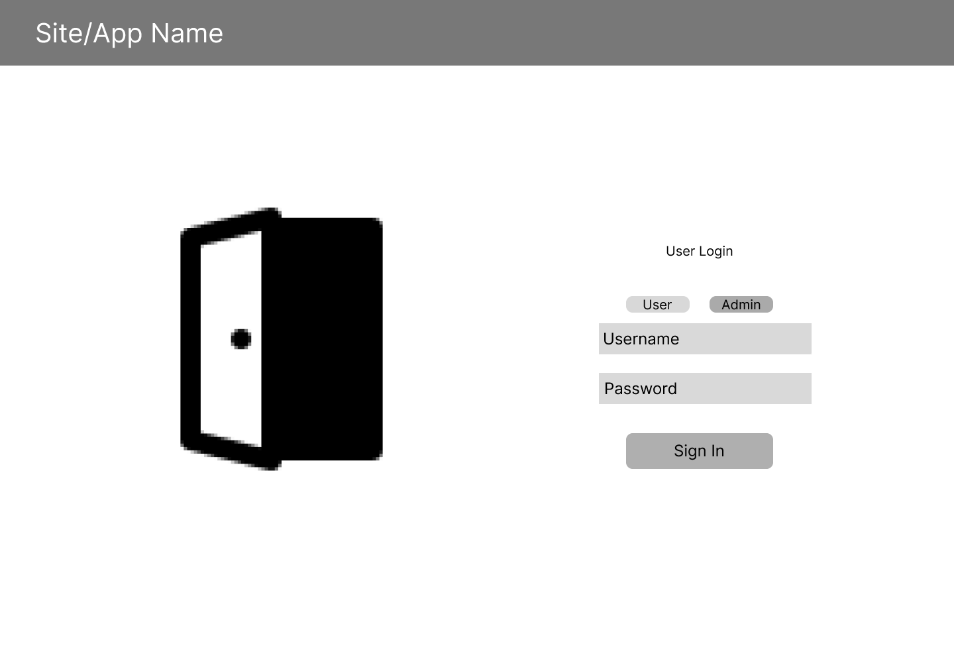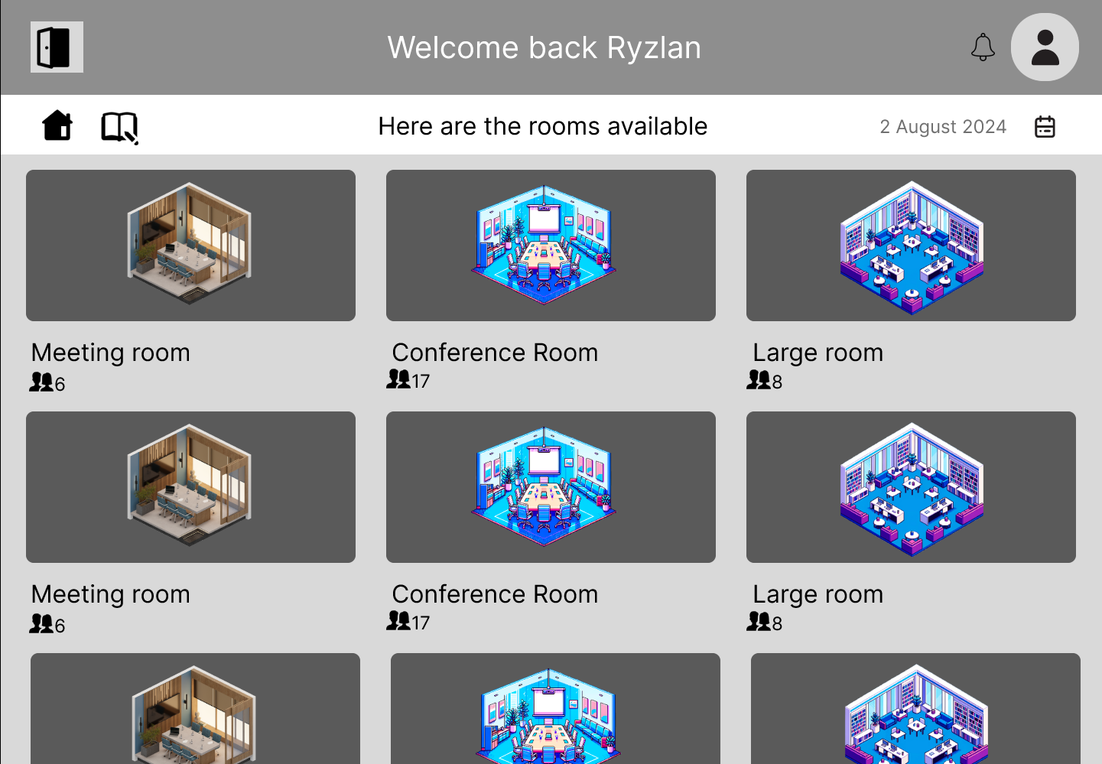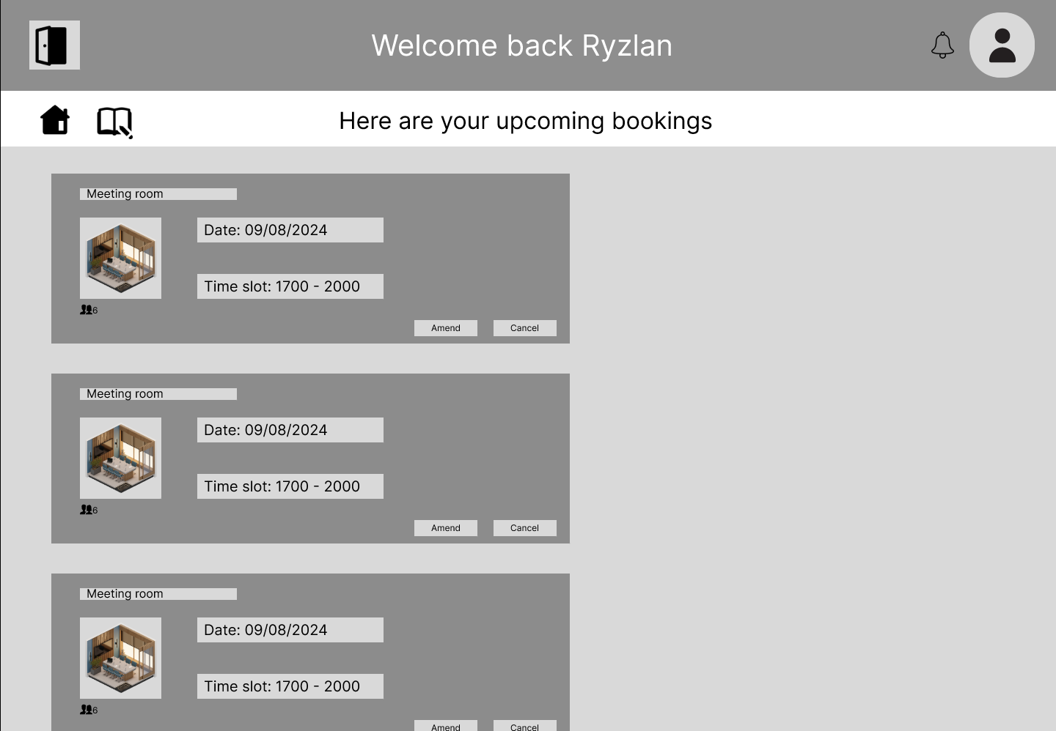
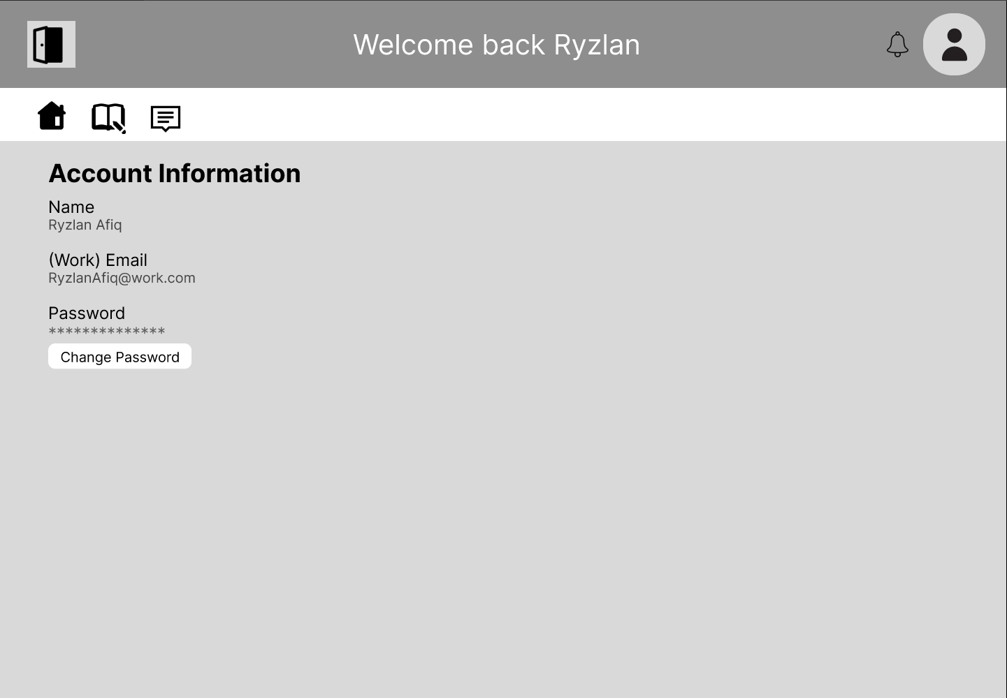
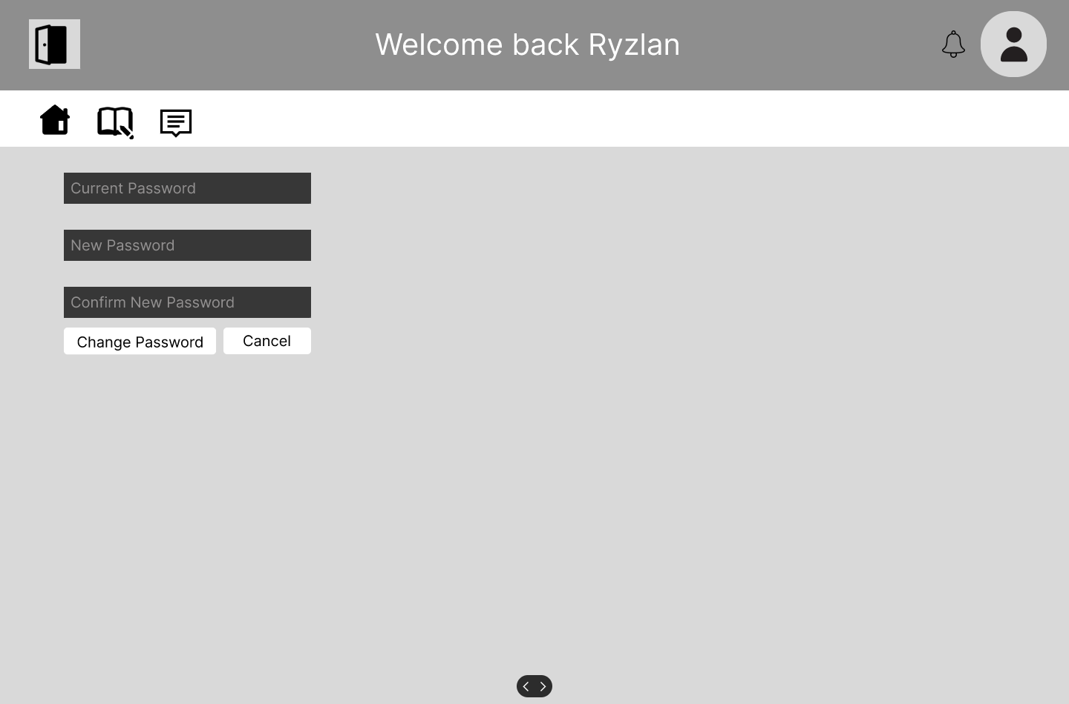
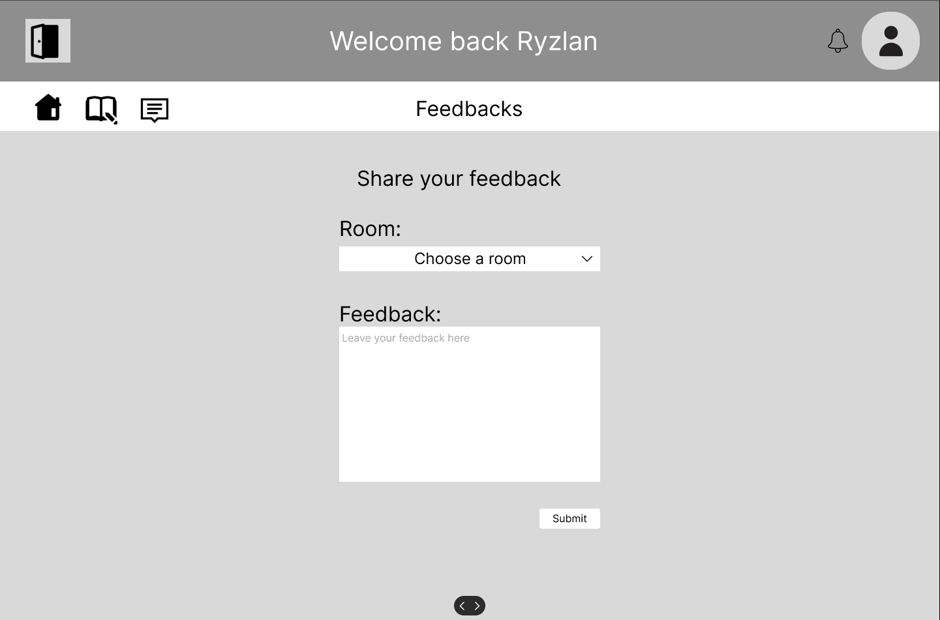
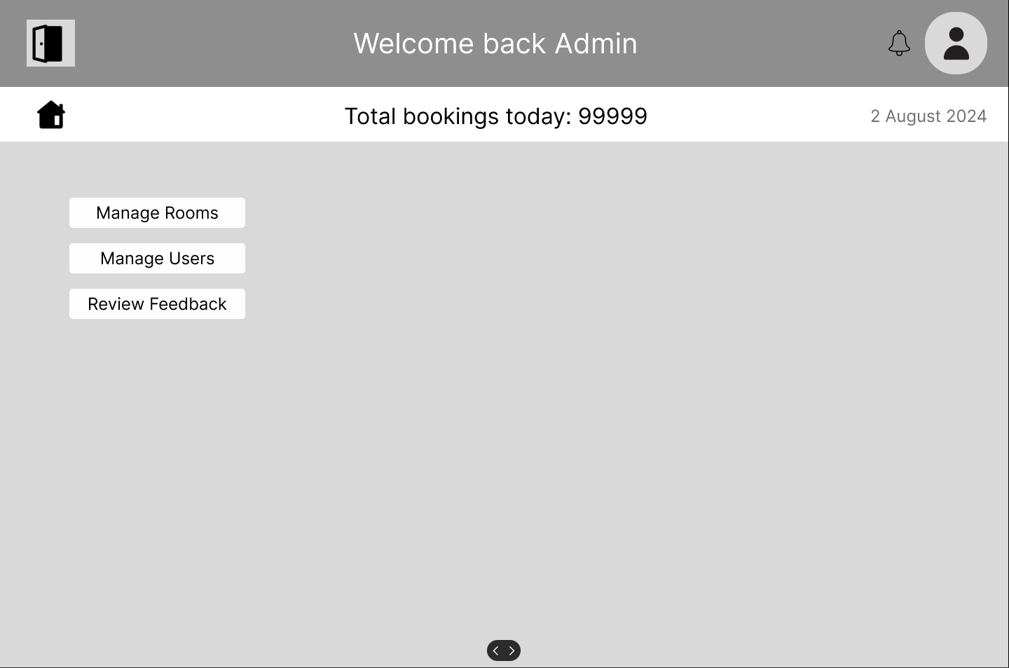

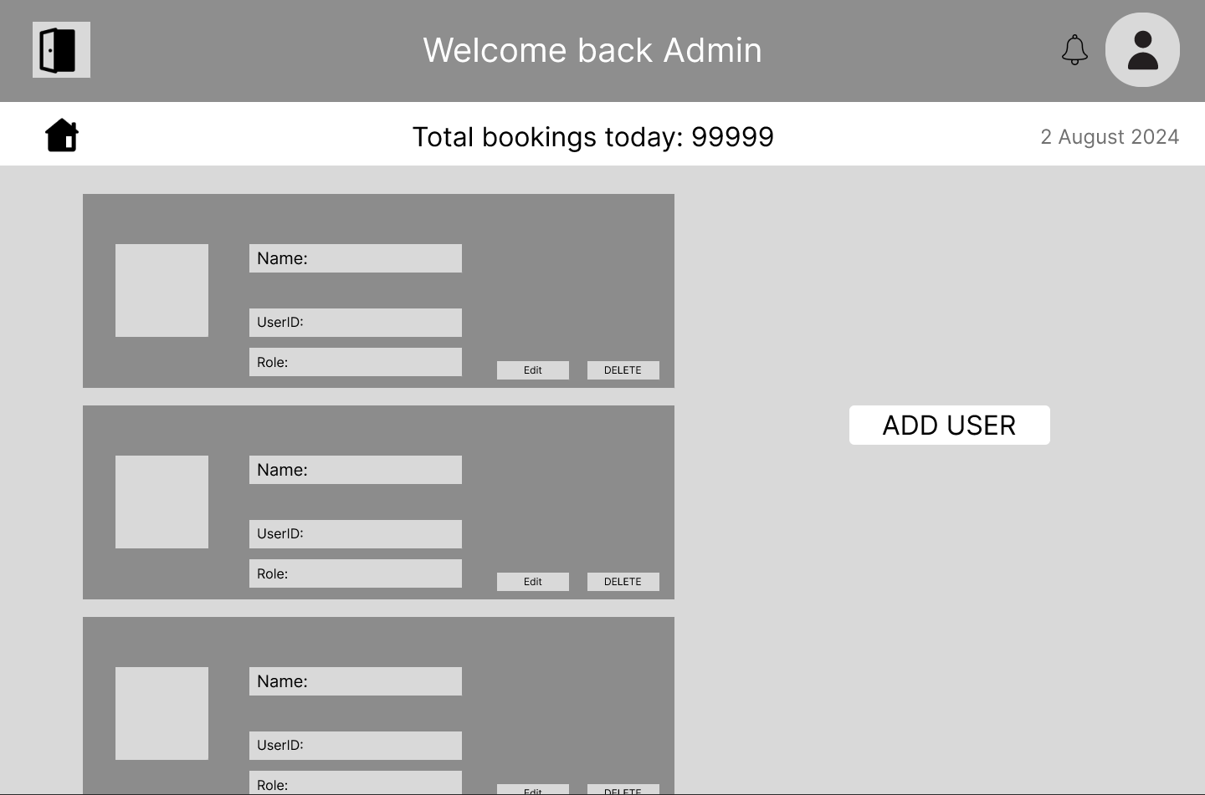

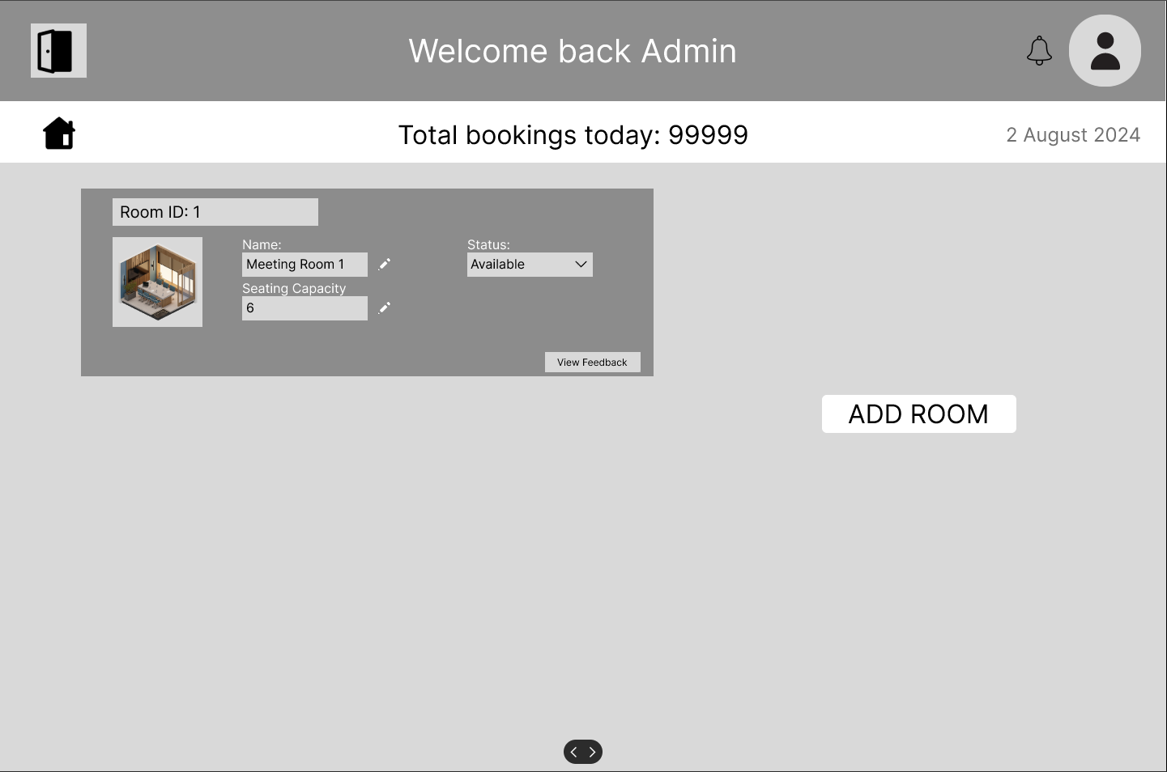
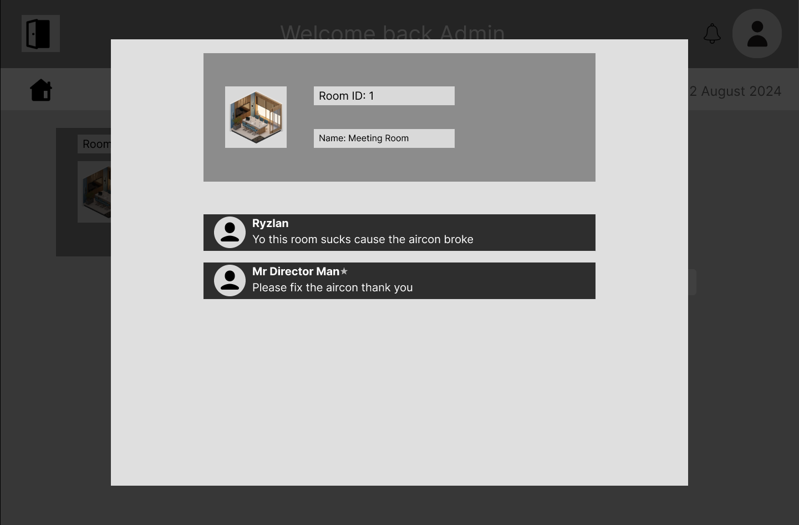
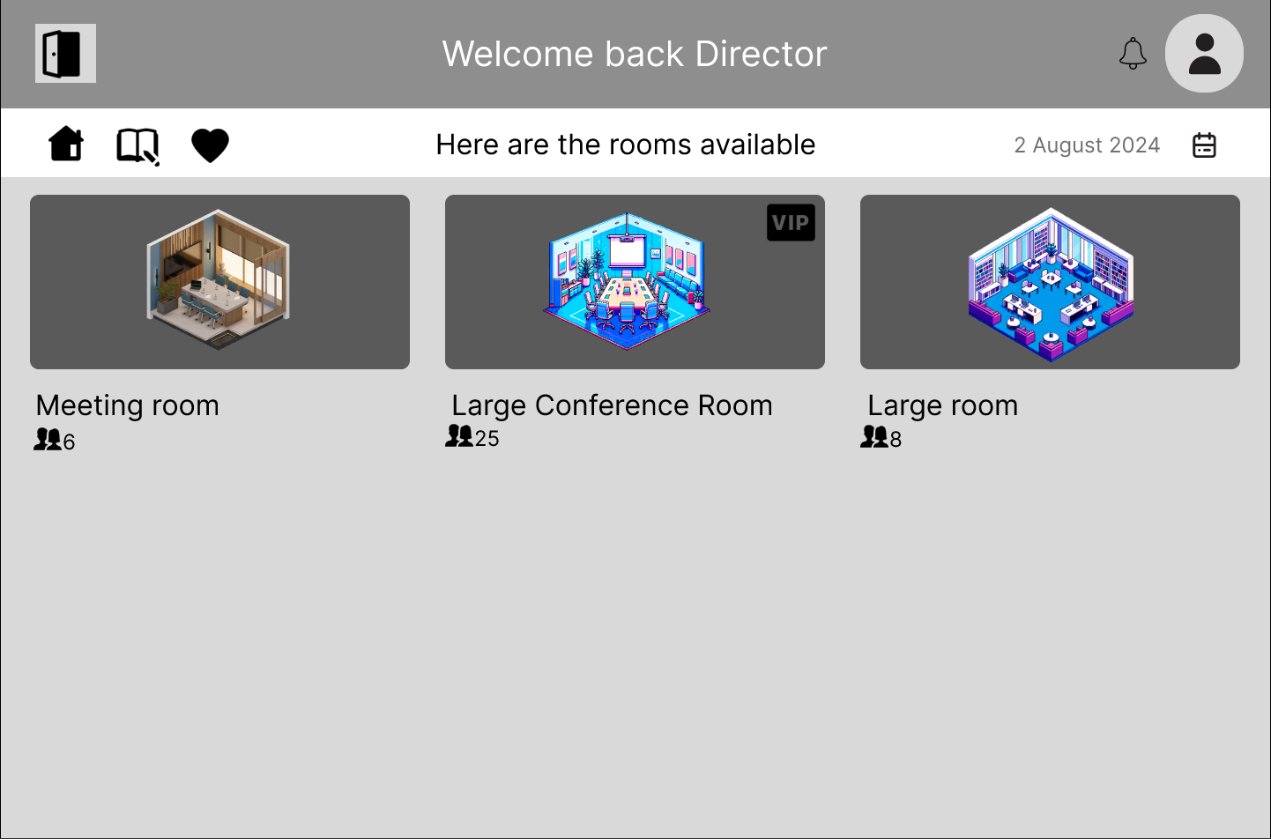
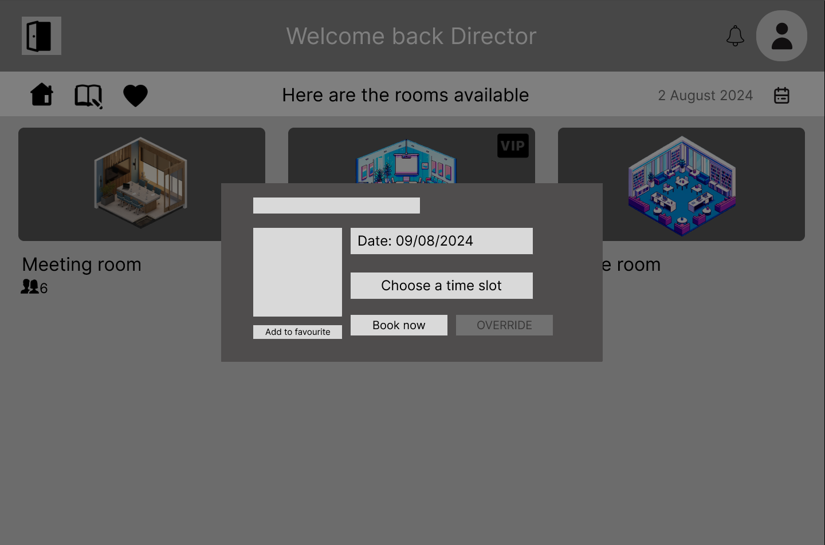
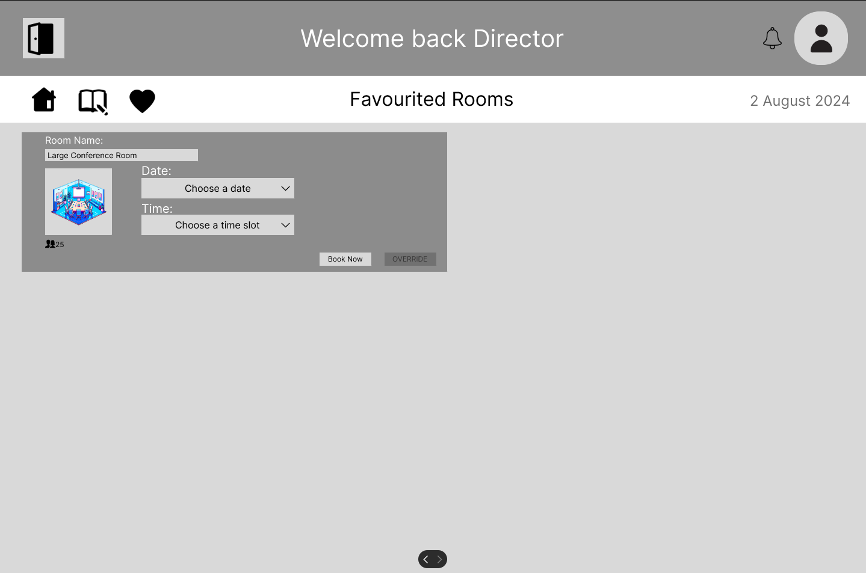

10.2 Mobile Application

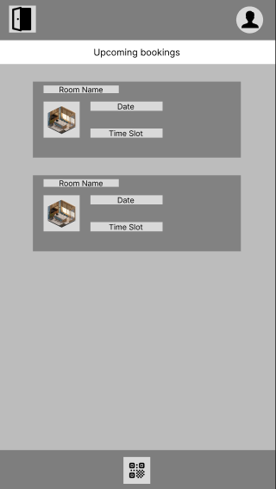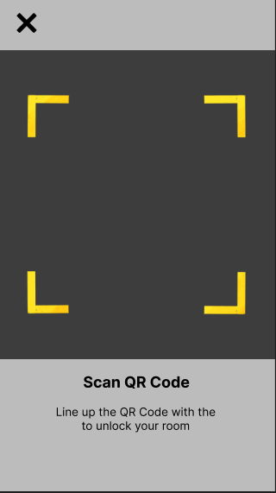

10.3 Public Site

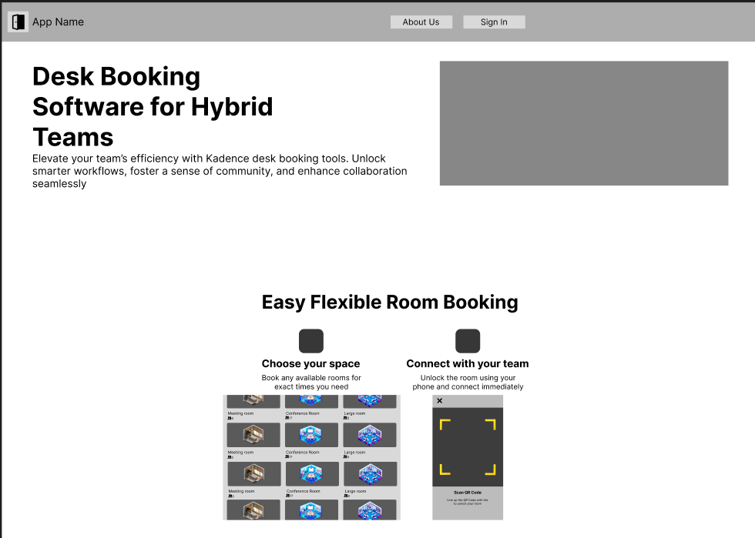

Meeting 1
Date: 08/07/2024
Meeting Objective: Allocating different roles to each team member.
Agenda:
- Allocate roles
- Agree on the responsibilities of the different roles
Discussion:
- Agree on using scrum framework
- Agree on scrum role
- Research on company that has similar function to our project

Name | Roles
Matthew Chin Yu Kang | Scrum Master
Randall Lim Shi Hao | Dev team
Teo Wei Zhi Zakary | Dev team
Mahina Lim Fong Jia | Dev team
Ryzlan Afiq Bin Roslan | Product Owner

Attendance
Matthew Chin Yu Kang | Present
Randall Lim Shi Hao | Present
Teo Wei Zhi Zakary | Present
Mahina Lim Fong Jia | Present
Ryzlan Afiq Bin Roslan | Present
Minutes done by : Mahina

Meeting 2
Date: 19/07/2024
Meeting Objective: Discussing and allocating tasks to the team
Agenda:
- Final report section 1 - 5
- Creating excel sheet to assign team members to complete tasks
Discussion:
- Agree on the team to split up to work
- Discussing what to write in each section of the final report
- Continuing research for mobile app database
- Continuing research for competitors pros and cons, value add
- Deciding which app we are creating (Room booking application)

Attendance
Matthew Chin Yu Kang | Present
Randall Lim Shi Hao | Present
Teo Wei Zhi Zakary | Present
Mahina Lim Fong Jia | Present
Ryzlan Afiq Bin Roslan | Present
Minutes done by : Matthew

Meeting 3
Date: 26/07/2024
Meeting Objective: Completing the (PRD)
Agenda:
- What else is left for PRD
- Creating user stories
- How many user user stories
- Define the requirements

Discussion:
- 3 actors, user, admin, and VIP
- 10 user stories per actor
- Complete functional requirements, non-functional requirements and other requirements
- Functional requirements - What the system should do, Clearly define a particular function or interaction.
- Non-functional requirements - quality attributes, They specify how the system performs a function
- Other requirements - System features, system requirements, system maintenance

Attendance
Matthew Chin Yu Kang | Present
Randall Lim Shi Hao | Present
Teo Wei Zhi Zakary | Present
Mahina Lim Fong Jia | Present
Ryzlan Afiq Bin Roslan | Present
Minutes done by : Matthew

Meeting 4
Date: 02/08/2024
Meeting Objective: -Completing the (PRD)
Agenda:
- Create functional and non-functional requirements.
- Finalise user stories for PRD.
- Complete business model
- Create wireframe
- Tidy up the tech stack
Discussion:
- Selecting NextJS for Fullstack language
- Tech stack for pro and cons, will be done by Zak
- Completing wire frame done by Ryzlan
- Business model will be done by Randall
- Non-functional and functional requirement done by Matthew and Mahina
- Finalise user stories done by Mahina and Matthew
- Purpose of project done by Zak

Attendance
Matthew Chin Yu Kang | Present
Randall Lim Shi Hao | Present
Teo Wei Zhi Zakary | Present
Mahina Lim Fong Jia | Present
Ryzlan Afiq Bin Roslan | Present
Minutes done by : Mahina

Meeting 5
Date: 09/08/2024
Meeting Objective: - Finalised PRD
Agenda:
- Finalised PRD
- What is need for september submission
- Discuss on use case description
Discussion:
- Continue the wireframe functionality that follow the user stories (Ryzlan)
- Double check the PRD before submission
- Deciding to do technical documentation report
- User - use case description webpage (Zak)
- Admin - use case description webpage (Randall)
- Director - Use case description webPage(Matthew)
- Tech stack for hosting Webpage (Matthew)
- Mobile User and Director Use case description(Mahina)
- Use case diagram all (Mahina)

Attendance
Matthew Chin Yu Kang | Present
Randall Lim Shi Hao | Present
Teo Wei Zhi Zakary | Present
Mahina Lim Fong Jia | Present
Ryzlan Afiq Bin Roslan | Present
Minutes done by : Mahina

Meeting 6
Date: 17/08/2024
Meeting Objective: - Starting Technical report
Agenda:
- Begin Sequence diagram for all user stories
- Sketch ERD diagram (mahina :))
- Start on prototype*
- Check Wire frame
- Check Use case description
Discussion:
- Distribute Task
- Check on the use case description, as there are some new user stories
- Check on the wireframe
- Sequence diagram (all)
- Matthew start on prototyping
- Rylzan will continue touching up on the wireframe.

Attendance
Matthew Chin Yu Kang | Present
Randall Lim Shi Hao | Present
Teo Wei Zhi Zakary | Present
Mahina Lim Fong Jia | Present
Ryzlan Afiq Bin Roslan | Present
Minutes done by : Mahina

Meeting 7
Date: 23/08/2024
Meeting Objective: - Continuing technical report
Agenda:
- Continue Sequence diagram
- Figma will be prototype
- Creating ERD diagram
Discussion:
- Zakary and Mahina will do wire frame
  - Zakary do Webpage
  - Mahine to Mobile
- Ryzlan will continue prototype using figma
- Matthew will take over Ryzlan sequence diagram
- Randall will do ERD diagram
- Next week no meeting due to the final exams.

Attendance
Matthew Chin Yu Kang | Present
Randall Lim Shi Hao | Present
Teo Wei Zhi Zakary | Present
Mahina Lim Fong Jia | Present
Ryzlan Afiq Bin Roslan | Present
Minutes done by : Matthew

Meeting 8
Date: 06/09/2024
Meeting Objective: - Update on Technical report and prototype
Agenda:
- check on all the progress sequence diagram
- Wireframe
- Check prototype
- For a presentation do you all need help?
Discussion:
- Rylzan showcase the webpage prototype work
- Check all everyone sequence diagram
- Thing to complete before next week meeting
  - Sequence diagram
  - ERD
  - Presentation Slides
  - Class diagram
  - Wireframe
  - Prototype
- Update WBS and Scrum

Attendance
Matthew Chin Yu Kang | Present
Randall Lim Shi Hao | Present
Teo Wei Zhi Zakary | Present
Mahina Lim Fong Jia | Present
Ryzlan Afiq Bin Roslan | Present
Minutes done by : Mahina

Meeting 9
Date: 13/09/2024
Meeting Objective: - Checking on Slides and Wireframe
Agenda:
- Go through Peer assessment
- Final check
  - Sequence diagram
  - Database Design
  - Presentation Slides (Max 20 slides)
  - Wireframe
  - Prototype
- Functional Hierarchy diagram need? (Ryzlan)
- Align the document name according to submission
Discussion:
- Final check mostly done
- Checking sequence
- Completing Presentation slides
- Ryzlan starting functional hierarchy diagram

Attendance
Matthew Chin Yu Kang | Present
Randall Lim Shi Hao | Present
Teo Wei Zhi Zakary | Present
Mahina Lim Fong Jia | Present
Ryzlan Afiq Bin Roslan | Present
Minutes done by : Matthew

Meeting 10
Date: 20/09/2024
Meeting Objective: - Checking on Slides start coding for login
Agenda:
- Host website
- Host database
- Connect website to database
- Connect mobile to database
- User stories:
  - Login for all actor (Web)
  - Login for all actor (mobile)
Discussion:
- Final check mostly done
- Trial run presentation
- Learning how to use github desktop from matthew
- Learning to connect website to database

Attendance
Matthew Chin Yu Kang | Present
Randall Lim Shi Hao | Present
Teo Wei Zhi Zakary | Present
Mahina Lim Fong Jia | Present
Ryzlan Afiq Bin Roslan | Present
Minutes done by : Matthew

Meeting 11
Date: 26/09/2024
Meeting Objective: - start coding on user and director
Agenda:
- Update about login
- User stories:
  - User Favourite
  - User booking
  - User feedback
Discussion:
- Check progress for login
  - Login is done for actor
  - Login for admin and director not done
- User stories:
  - User Favourite (Ryzlan )
  - User booking (matthew)
  - User feedback (Zakary )
  - Mobile user view (Randall, Mahina)

Attendance
Matthew Chin Yu Kang | Present
Randall Lim Shi Hao | Present
Teo Wei Zhi Zakary | Present
Mahina Lim Fong Jia | Present
Ryzlan Afiq Bin Roslan | Present
Minutes done by : Matthew

Meeting 12
Date: 04/10/2024
Meeting Objective: - Finish up user and director coding and start Admin (webpage)
Agenda:
- Issue with mobile
- User stories progression
Discussion:
- Director and user that is incomplete:
  - Admin Navbar (Webpage)
  - Admin Homepage (Webpage)
  - Admin View Feedback (Webpage)
  - Login (mobile)
  - View booking (mobile)
- Matthew finalise the user and director code
- For Mobile will be using spring boot to access the database
  - Spring boot is an server API (Mahina and Zakary)

Attendance
Matthew Chin Yu Kang | Present
Randall Lim Shi Hao | Present
Teo Wei Zhi Zakary | Present
Mahina Lim Fong Jia | Present
Ryzlan Afiq Bin Roslan | Present
Minutes done by : Mahina

Meeting 13
Date: 11/10/2024
Meeting Objective: - Finish up user and director coding and start Admin (webpage)
Agenda:
- Left 2 functions for web page (director override home page, admin unlock user account)
- Check phone can use face or fingerprint
- Ask Zongfu if we can use webpage to process the fingerprint or face recognition
- Get the ball rolling for biometrics.
- Finish up mobile app
- Test case for webpage
Discussion:
- Ryzlan - Admin unlock user
- Zak, Ryz, Matthew - Director homepage override
- Ryzlan - Check phone can use face or fingerprint
- Zak, Mahina - Get the ball rolling for biometrics.
- Randal, Mahina - Finish up mobile app (View, Scan)
- Matthew - Test cases

Attendance
Matthew Chin Yu Kang | Present
Randall Lim Shi Hao | Present
Teo Wei Zhi Zakary | Present
Mahina Lim Fong Jia | Present
Ryzlan Afiq Bin Roslan | Present
Minutes done by : Matthew

Meeting 14
Date: 18/10/2024
Meeting Objective: - Starting Documents and fix bugs
Agenda:
- Email 2FA for mobile (for door pin number )
- Bug fixes
- User manual
- Test cases
- Mobile account lockout
Discussion:
- Email 2FA for mobile (for door pin number ) - Mahina
- Bug fixes - Ryzlan, Zak
- User manual - Randall
- Test cases - Matthew
- Mobile account lockout - Mahina

Attendance
Matthew Chin Yu Kang | Present
Randall Lim Shi Hao | Present
Teo Wei Zhi Zakary | Present
Mahina Lim Fong Jia | Present
Ryzlan Afiq Bin Roslan | Present
Minutes done by : Matthew

Meeting 15
Date: 25/10/2024
Meeting Objective: - Completing more documents and last 2-3 functions
Agenda:
- Break glass protocol
- Email notification of override (website)
- Sequence diagram
- User manual deployment
- Update database for BGP
- Research on BGP - ETC NIST policy
- Test Cases - Admin
- Test Cases- Mobile

Discussion:
- Break glass protocol - Mahina
- Email notification of override (website) - Zak
- Sequence diagram - Ryzlan & Randall
- User manual deployment - Matthew
- Update database for BGP - Zak
- Research on BGP - NIST policy - Randall
- Test Cases - Admin - Matthew
- Test Cases- Mobile - Mahina & Ryzlan
- Generate 12 character for master pin (website) - Matthew

Attendance
Matthew Chin Yu Kang | Present
Randall Lim Shi Hao | Present
Teo Wei Zhi Zakary | Present
Mahina Lim Fong Jia | Present
Ryzlan Afiq Bin Roslan | Present
Minutes done by : Matthew

Meeting 16
Date: 01/11/2024
Meeting Objective: - Continue Documents and fix bugs
Agenda:
- Use case description
- Video
- Data Transfer diagram
- ERD diagram
- Populate DB
Discussion:
- Use case description (Admin) - Ryzlan
- Use case description (User) - Matthew
- Use case description (Director) - Randall
- Use case description (Mobile) - Mahina
- Video recording (Mobile) - All (Tuesday 12pm)
- Video recording (Website) - Randall
- Video editing - Ryzlan
- Data Transfer diagram - Mahina
- ERD diagram - Zak
- Populate DB - Zak

Attendance
Matthew Chin Yu Kang | Present
Randall Lim Shi Hao | Present
Teo Wei Zhi Zakary | Present
Mahina Lim Fong Jia | Present
Ryzlan Afiq Bin Roslan | Present
Minutes done by : Matthew

Meeting 17
Date: 08/11/2024
Meeting Objective: - Second final check
Agenda:
- Start doing slide
- Thing that not complete
- Remind them do reflection
- Peer evaluation
Discussion:
- Distribute the slide
- backlog
  - Sequence diagram override
  - Editing video
  - Reflection
  - Peer evaluation
  - Final check with code

Attendance
Matthew Chin Yu Kang | Present
Randall Lim Shi Hao | Present
Teo Wei Zhi Zakary | Present
Mahina Lim Fong Jia | Present
Ryzlan Afiq Bin Roslan | Present
Minutes done by : Mahina

Meeting 18
Date: 15/11/2024
Meeting Objective: - Final meeting
Agenda:

Discussion:

Attendance
Matthew Chin Yu Kang | Present
Randall Lim Shi Hao | Present
Teo Wei Zhi Zakary | Present
Mahina Lim Fong Jia | Present
Ryzlan Afiq Bin Roslan | Present
Minutes done by : Matthew

